|  |  |
| --- | --- |
| **TITLE:** LAMBTON DATABASE SYSTEMS | |
| **GROUP NO :** 5 | |
| **SUBJECT CODE:** CSD2204 | |
| **SUBJECT NAME:** DATABASE DESIGN & SQL | |
| **MEMBER NAME** | **MEMBER NO** |
| Swetha Shanmugam | C0713440 |
| Kalpana Ramanan | C0715368 |

|  |  |
| --- | --- |
| **S.No** | **TABLE OF CONTENT** |
|  | OVERVIEW TO LAMBTON DATABASE SYSTEMS |
|  | LEARNING AND DIFFUCLITES TOWARDS THE PATHWAY |
|  | TOOLD USED |
|  | ER DIAGRAMS |
|  | TABLE STRUCTURE |
|  | QUERIES   1. CREATE QUERIES 2. INSERT QUERIES 3. SELECT QUERIES |
|  | REFRENCES |

OVERVIEW TO LAMBTON DATABASE SYSTEMS

* A college contains many departments.
* Each department can offer any number of courses.
* Many instructors can work in a department, but an instructor can work only in one department.
* For each department, there is a head, and an instructor can be head of only one department.
* Each instructor can take any number of courses, and a course can be taken by only one instructor.
* A student can enroll for any number of courses and each course can have any number of students.
* The database created here contains the various information about the updated college portal.

LEARNT FROM LAMBTON DATABASE SYSTEM:

* Information retrieval system
* Centralised available databases
* Databases at college can be connected using any piece of information from any table (if authorised by eg: student and faculty)
* Simplifies access
* Helps users to locate information resources.

DIFFICULTIES TOWARDS THE PATHWAY:

* To compare the tables which are not related to each other except some fields.
  + - There is a significant issue that makes the above relationships between students and courses more complex.
    - Any student can be enrolled in multiple courses.
    - Any course can have multiple students.
    - This is very important! Because of such "multiplicity" we have to add a new entity, namely, the Section:
    - Course ------has------> Section <-----enroll------ Students
    - Or in plain English, "Course has sections", "Students enroll in sections".

TOOLS USED:

* Lucidchart
* XAMPP Control Panel v3.2.2
* MYSQL database version 10.1.21-MariaDB

ENTITY RELATIONSHIP(ER) DIAGRAM:

REFERE THE BELOW LINK

<https://www.lucidchart.com/invitations/accept/bbb59725-875a-4127-82a9-f6a05cd4559b>

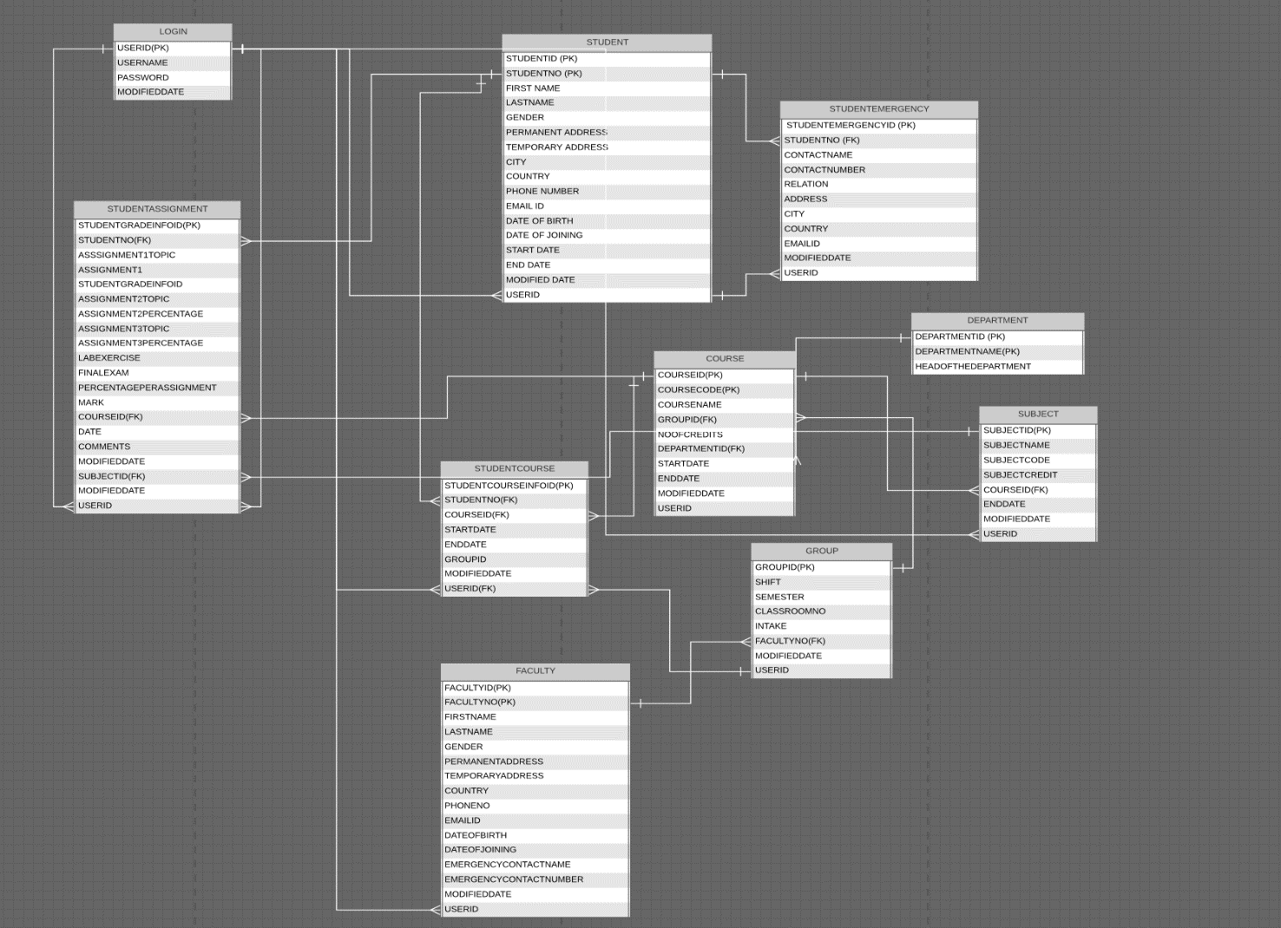

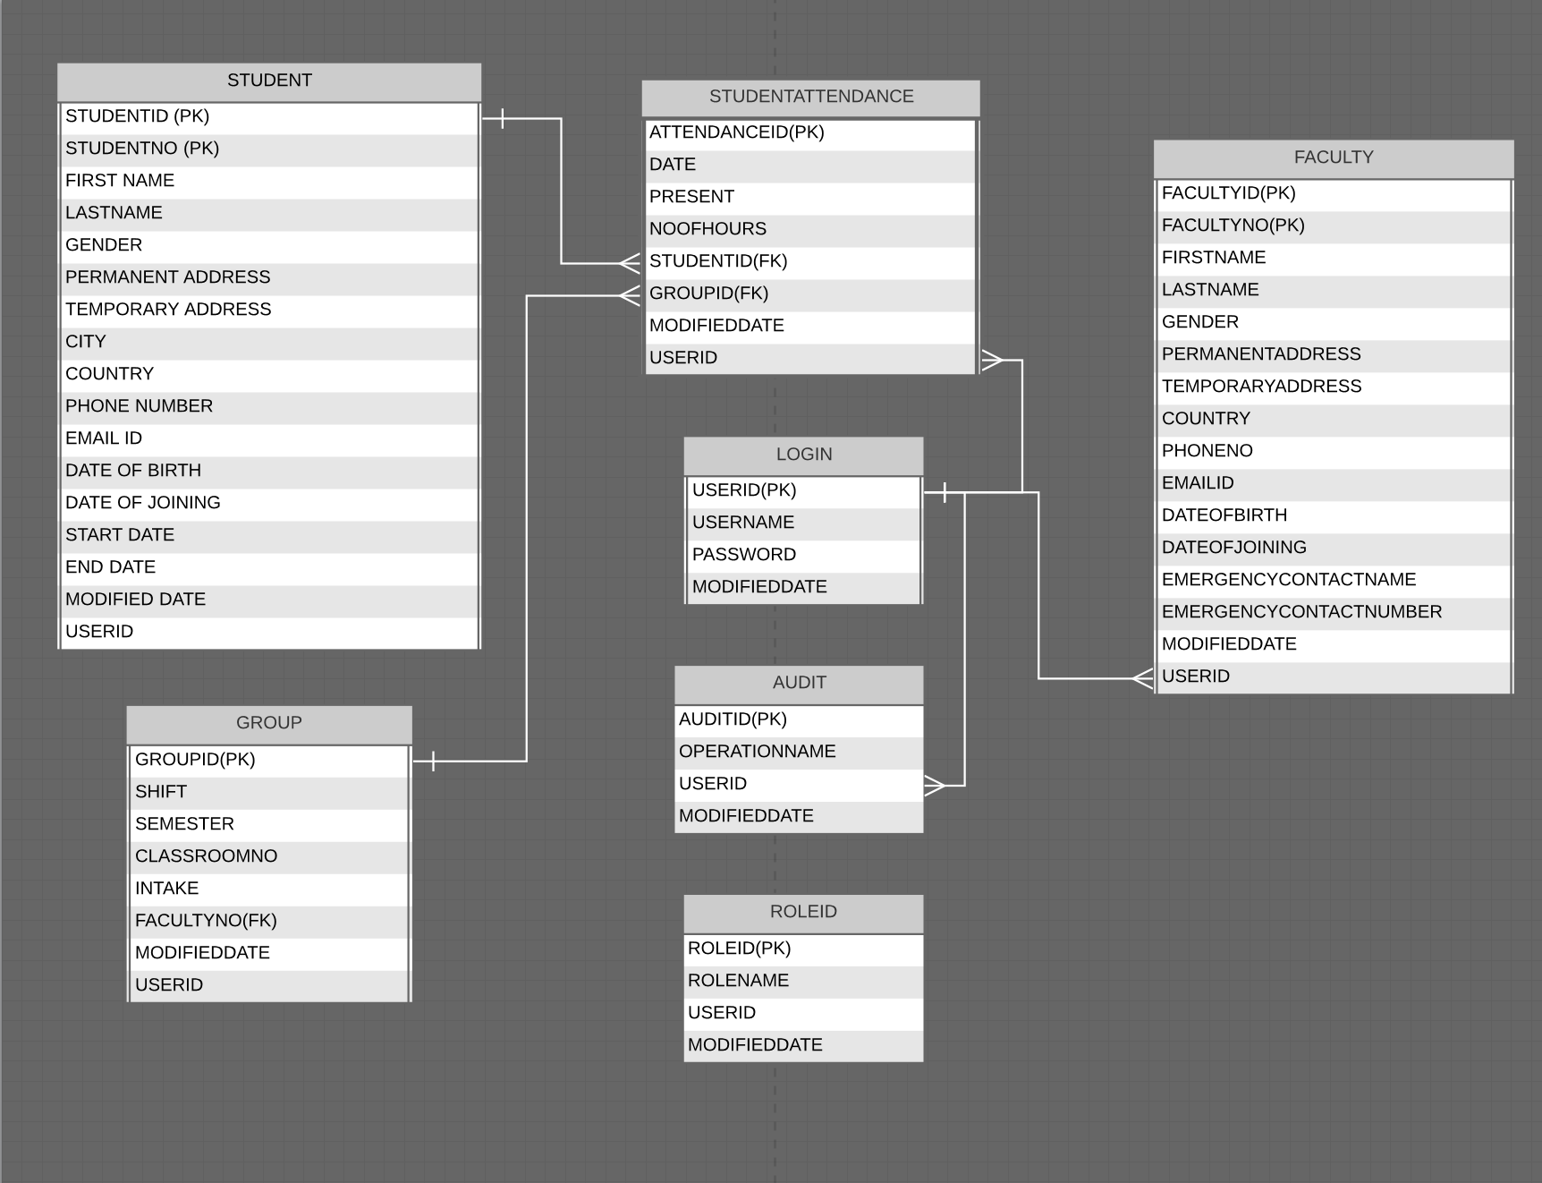

TABLES STRUCTURE:

**LIST OF TABLES**

1. STUDENT
2. STUDENTEMERGENCY
3. DEPARTMENT
4. COURSE
5. SUBJECT
6. GROUPS
7. STUDENTCOURSE
8. STUDENTASSIGNMENT
9. FACULTY
10. STUDENTATTENDANCE
11. LOGIN
12. ROLES
13. AUDIT(Optional)

**Table: STUDENT**

**Primary Key: STUDENTID, STUDENTNO**

**Description: This table contains all basic information about the Student.**

|  |  |  |
| --- | --- | --- |
| **Column Name** | **Data Type** | **CONSTRAINTS** |
| **STUDENTID** | **INTEGER(10)** | **PRIMARY KEY, AUTO\_INCREMENT** |
| **STUDENTNO** | **VARCHAR(50)** | **PRIMARY KEY** |
| FIRSTNAME | VARCHAR(50) | NOT NULL |
| LASTNAME | VARCHAR(50) | NOT NULL |
| GENDER | VARCHAR(50) | NOT NULL |
| PERMANENTADDRESS | VARCHAR(50) | NOT NULL |
| TEMPORARYADDRESS | VARCHAR(50) | NULL |
| CITY |  | NOT NULL |
| COUNTRY | VARCHAR(50) | NOT NULL |
| PHONENO | INTEGER(50) | NOT NULL |
| EMAILID | VARCHAR (50) | NOT NULL |
| DATEOFBIRTH | DATE | NOT NULL  (Date of Birth no greater than Current Date and Date of Joining no less than Date of Birth) |
| DATEOFJOINING | DATE | NOT NULL  (Date of joining should be greater than Date of Birth) |
| STARTDATE | DATE | NOT NULL |
| ENDDATE | DATE | NOT NULL |
| **MODIFIEDDATE** | **DATE** | **DEFAULT “TODAY DATE”** |
| **ISDELETED** | **Boolean** | **DEFAULT “TRUE”** |
| **USERID** | **VARCHAR(50)** | **CURRENT USER** |

**Table: STUDENTEMERGENCY**

**Primary Key: STUDENTID, STUDENTNO**

**Description: This table contains Emergency details about the Student.**

|  |  |  |
| --- | --- | --- |
| **Column Name** | **Data Type** | **CONSTRAINTS** |
| **STUDENTEMERGENCYID** | **INTEGER(10)** | **PRIMARY KEY, AUTO\_INCREMENT** |
| **STUDENTNO** | **VARCHAR(50)** | **FOREIGN KEY REFRENCES STUDENTNO FROM STUDENT TABLE** |
| CONTACTNAME | VARCHAR (50) | NULL |
| CONTACTNUMBER | INTEGER(50) | NULL |
| RELATION | VARCHAR (50) | NULL |
| ADDRESS | VARCHAR (50) | NULL |
| CITY | VARCHAR (15) | NULL |
| COUNTRY | VARCHAR(50) | NOT NULL |
| EMAILID | VARCHAR (50) | NOT NULL |
| **MODIFIEDDATE** | **DATE** | **DEFAULT “TODAY DATE”** |
| **ISDELETED** | **Boolean** | **DEFAULT “TRUE”** |
| **USERID** | **VARCHAR(50)** | **CURRENT USER** |

**Table: DEPARTMENT**

**Primary Key: DEPARTMENTID, DEPARTMENTNO**

**Description: This table contains all information about the Departments in the College.**

|  |  |  |
| --- | --- | --- |
| **Column Name** | **Data Type** | **CONSTRAINTS** |
| **DEPARTMENTID** | **INTEGER(10)** | **PRIMARY KEY, AUTO\_INCREMENT** |
| **DEPARTMENTNO** | **VARCHAR (50)** | **PRIMARY KEY** |
| DEPARTMENTNAME | VARCHAR (50) | NOT NULL |
| HEADOFTHEDEPARTMENT | VARCHAR (50) | NOT NULL |

**Table: COURSE**

**Primary Key: COURSEID, COURSECODE**

**Description: This table contains all course information in each department.**

|  |  |  |
| --- | --- | --- |
| **Column Name** | **Data Type** | **CONSTRAINTS** |
| **COURSEID** | **INTEGER(10)** | **PRIMARY KEY, AUTO\_INCREMENT** |
| **COURSECODE** | **VARCHAR(50)** | **PRIMARY KEY** |
| COURSENAME | VARCHAR(50) | NOT NULL |
| NOOFCREDITS | INTEGER(10) | DEFAULT “1” |
| DEPARTMENTID | INTEGER(10) | FOREIGN KEY REFRENCES DEPARTMENTID FROM DEPARTMENT |
| STARTDATE | Date | NOT NULL |
| ENDDATE | Date | NOT NULL |
| **MODIFIEDDATE** | **DATE** | **DEFAULT “TODAY DATE”** |
| **ISDELETED** | **Boolean** | **DEFAULT “TRUE”** |
| **USERID** | **VARCHAR(50)** | **CURRENT USER** |

**Table: SUBJECT**

**Primary Key: SUBJECTID**

**Description: This table contains all subject Details.**

|  |  |  |
| --- | --- | --- |
| **Column Name** | **Data Type** | **CONSTRAINTS** |
| **SUBJECTID** | **INTEGER(10)** | **PRIMARY KEY, AUTO\_INCREMENT** |
| SUBJECTNAME | VARCHAR(50) | NOT NULL |
| SUBJECTCODE | INTEGER(10) | NOT NULL |
| SUBJECTCREDIT | INTEGER(10) | DEFAULT “1” |
| COURSEID | INTEGER(10) | FOREIGN KEY REFRENCES COURSEID FROM COURSE |
| ENDDATE | DATE |  |
| **MODIFIEDDATE** | **DATE** | **DEFAULT “TODAY DATE”** |
| **ISDELETED** | **Boolean** | **DEFAULT “TRUE”** |
| **USERID** | **VARCHAR(50)** | **CURRENT USER** |

**Table: GROUP**

**Primary Key: GROUPID**

**Description: This table contains group information.**

|  |  |  |
| --- | --- | --- |
| **Column Name** | **Data Type** | **CONSTRAINTS** |
| **GROUPID** | **INTEGER(10)** | **PRIMARY KEY, AUTO\_INCREMENT** |
| SHIFT | VARCHAR (50) | NOT NULL |
| SEMESTER | VARCHAR (50) | NOT NULL |
| CLASSROOMNO | VARCHAR (50) | NOT NULL |
| INTAKE | VARCHAR (50) | NOT NULL |
| FACULTYID | VARCHAR (50) | FOREIGN KEY REFRENCES FACULTYCODE FROM FACULTY TABLE |
| **MODIFIEDDATE** | **DATE** | **DEFAULT “TODAY DATE”** |
| **ISDELETED** | **Boolean** | **DEFAULT “TRUE”** |
| **USERID** | **VARCHAR(50)** | **CURRENT USER** |

**Table: STUDENTCOURSE**

**Primary Key: STUDENTCOURSEINFOID**

**Description: This table contains all information about the Student on which subject/course he/she registered.**

|  |  |  |
| --- | --- | --- |
| **Column Name** | **Data Type** | **CONSTRAINTS** |
| **STUDENTCOURSEINFOID** | **INTEGER(10)** | **PRIMARY KEY, AUTO\_INCREMENT** |
| STUDENTNO | VARCHAR(50) | FOREIGN KEY REFRENCES STUDENTNO FROM STUDENT TABLE |
| COURSEID | INTEGER(10) | FOREIGN KEY REFRENCES COURSEID FROM COURSE TABLE |
| STARTDATE | DATE | CURRENT DATE |
| ENDDATE | DATE | CURRENT DATE |
| GROUPID | INTEGER(10) | FOREIGN KEY REFRENCES GROUPID FROM GROUP TABLE |
| **MODIFIEDDATE** | **DATE** | **DEFAULT “TODAY DATE”** |
| **ISDELETED** | **Boolean** | **DEFAULT “TRUE”** |
| **USERID** | **VARCHAR(50)** | **CURRENT USER** |

**Table: STUDENTASSIGNMENT**

**Primary Key: STUDENTGRADEINFOID**

**Description: This table contains all Assignment details of the student.**

|  |  |  |
| --- | --- | --- |
| **Column Name** | **Data Type** | **CONSTRAINTS** |
| **STUDENTGRADEINFOID** | **INTEGER(10)** | **PRIMARY KEY, AUTO\_INCREMENT** |
| STUDENTNO | VARCHAR(50) | FOREIGN KEY REFRENCES STUDENTNO FROM STUDENT TABLE |
| ASSIGNMENT1TOPIC | VARCHAR (50) |  |
| ASSIGNMENT1PERCENTAGE | INTEGER(10) |  |
| ASSIGNMENT2TOPIC | VARCHAR (50) |  |
| ASSIGNMENT2PERCENTAGE | INTEGER(10) |  |
| ASSIGNMENT3TOPIC | VARCHAR (50) |  |
| ASSIGNMENT3PERCENTAGE | INTEGER(10) |  |
| LABEXERCISE | INTEGER(10) |  |
| FINALEXAM | INTEGER(10) |  |
| PERCENTAGEPERASSIGNEMENT | INTGEGER(10) | NOT NULL |
| MARK | FLOAT(10,2) | DEFAULT 0.0 |
| COURSEID | INTEGER(10) | FOREIGN KEY REFRENCES COURSEID FROM COURSE |
| DATE | DATE |  |
| COMMENTS | VARCHAR (50) |  |
| MODIFIEDDATE | DATE | DEFAULT TODAY DATE |
| SUBJECTID | INTEGER(10) | FOREIGN KEY REFRENCES  SUBJECTID FROM SUBJECT |
| **MODIFIEDDATE** | **DATE** | **DEFAULT “TODAY DATE”** |
| **ISDELETED** | **Boolean** | **DEFAULT “TRUE”** |
| **USERID** | **VARCHAR(50)** | **CURRENT USER** |

**Table: FACULTY**

**Primary Key: FACULTYID**

**Description: This table contains all basic information about the Faculty.**

|  |  |  |
| --- | --- | --- |
| **Column Name** | **Data Type** | **CONSTRAINTS** |
| **FACULTYID** | **INTEGER(10)** | **PRIMARY KEY, AUTO\_INCREMENT** |
| FACULTYNO | VARCHAR(50) | PRIMARY KEY |
| FIRSTNAME | VARCHAR(50) | NOT NULL |
| LASTNAME | VARCHAR(50) | NOT NULL |
| GENDER | VARCHAR(50) | NOT NULL |
| PERMANENTADDRESS | VARCHAR(50) | NOT NULL |
| TEMPORARYADDRESS | VARCHAR(50) | NOT NULL |
| COUNTRY | VARCHAR(50) | NOT NULL |
| PHONENO | INTEGER(50) | NOT NULL |
| EMAILID | VARCHAR (50) | NOT NULL |
| DATEOFBIRTH | DATE |  |
| DATEOFJOINING | DATE |  |
| EMERGENCYCONTACTNAME | VARCHAR (50) | NULL |
| EMERGENCYCONTACTNUMBER | INTEGER(50) | NULL |
| **MODIFIEDDATE** | **DATE** | **DEFAULT “TODAY DATE”** |
| **ISDELETED** | **Boolean** | **DEFAULT “TRUE”** |
| **USERID** | **VARCHAR(50)** | **CURRENT USER** |

**Table: STUDENTATTENDANCE**

**Primary Key: ATTENDANCEID**

**Description: This table contains Student attendance.**

|  |  |  |
| --- | --- | --- |
| **Column Name** | **Data Type** | **CONSTRAINTS** |
| **ATTENDANCEID** | **INTEGER(10)** | **PRIMARY KEY, AUTO\_INCREMENT** |
| DATE | DATE |  |
| PRESENT | Boolean | DEFAULT “NO” |
| NOOFHOURS | INTEGER(10) | DEFAULT ‘5’ |
| STUDENTNO | VARCHAR(50) | FOREIGN KEY REFRENCES STUDENTNO FROM STUDENT TABLE |
| GROUPID | INTEGER(10) | FOREIGN KEY REFRENCES GROUPID FROM GROUP TABLE |
| **MODIFIEDDATE** | **DATE** | **DEFAULT “TODAY DATE”** |
| **ISDELETED** | **Boolean** | **DEFAULT “TRUE”** |
| **USERID** | **VARCHAR(50)** | **CURRENT USER** |

**Table: LOGIN**

**Primary Key: USERID**

**Description: This table contains user login details.**

|  |  |  |
| --- | --- | --- |
| **Column Name** | **Data Type** | **CONSTRAINTS** |
| **USERID** | **INTEGER(10)** | **PRIMARY KEY** |
| USERNAME | VARCHAR(50) |  |
| PASSWORD | VARCHAR(50) |  |
| **MODIFEIDDATE** | **DATE** | **CURRENT DATE** |

**Table: ROLES**

**Primary Key: ROLEID**

**Description: This table role information of the Lambton Database.**

|  |  |  |
| --- | --- | --- |
| **Column Name** | **Data Type** | **CONSTRAINTS** |
| **ROLEID** | **VARCHAR(50)** | **PRIMARY KEY** |
| ROLENAME | VARCHAR(50) |  |
| **USERID** | **INTEGER(10)** | **CURRENT USER ID** |
| **MODIFEIDDATE** | **DATE** | **CURRENT DATE** |

**Table: AUDIT (Optional Table)**

**Primary Key: AUDITID**

**Description: This table contains audit log details.**

|  |  |  |
| --- | --- | --- |
| **Column Name** | **Data Type** | **CONSTRAINTS** |
| **AUDITID** | **INTERGER** | **PRIMARY KEY, AUTO INCREMENT** |
| OPERATIONNAME | VARCHAR(50) |  |
| **USERID** | **INTEGER(10)** | **CURRENT USER ID** |
| **MODIFEIDDATE** | **DATE** | **CURRENT DATE** |

QUERIES:

1. REFER THE BELOW LINK FOR CREATE SYNTAX

LINK: <LAMBTON_DATABASE_CREATE_QUERIES.txt>

FILE NAME: LAMBTON\_DATABASE\_CREATE\_QUERIES.txt

b. REFER THE BELOW LINK FOR INSERT SYSTAX

LINK: <LAMBTON_DATABASE_INSERT_SCRIPT.txt>

FILE NAME: LAMBTON\_DATABASE\_INSERT\_SCRIPT.txt

c. REFER THE BELOW LINK FOR SELECT AND DESC OF TABLES

LINK: <LAMBTON_DATABASE_SELECT_QUERIES.txt>

FILE NAME: LAMBTON\_DATABASE\_SELECT\_QUERIES.txt

SAMPLE OUTPUT DISPLAYED BELOW

1. **LIST A PARTICULAR STUDENT BASIC INFORMATION DETAILS**

**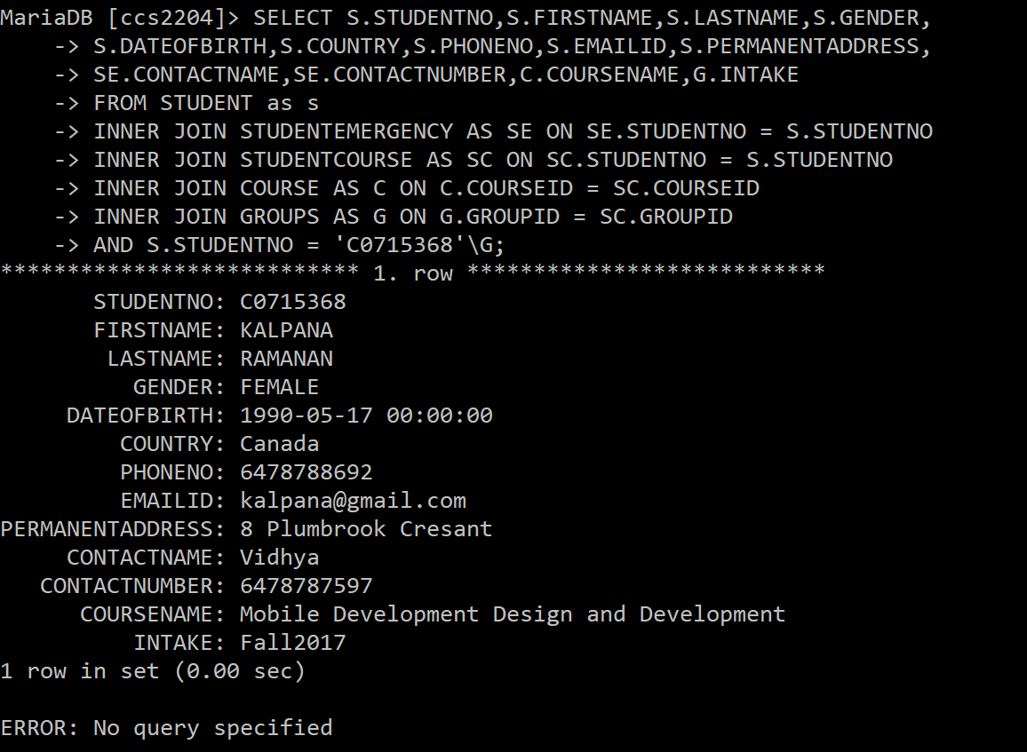**

1. **LIST A PARTICULAR STUDENT SUBJECT AND COURSE DETAIL**

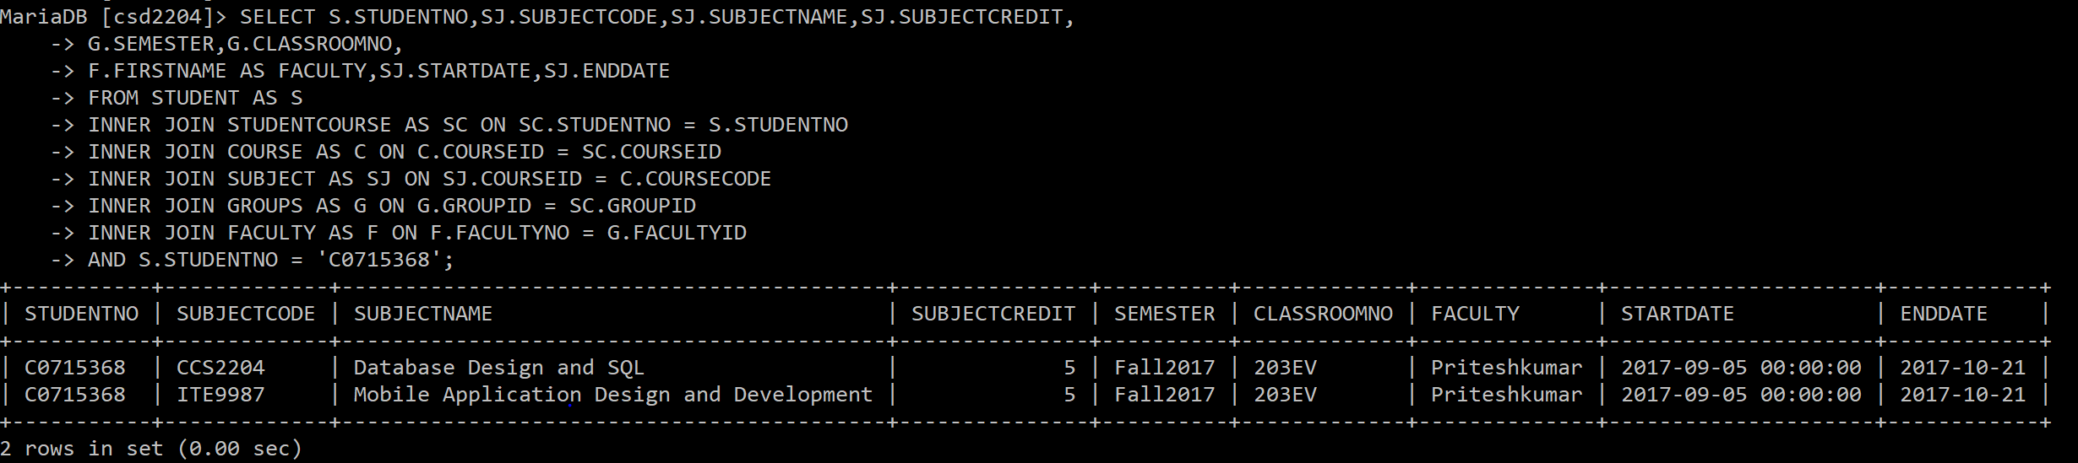

1. **LIST THE STUDENT FOR A PARTICULAR FACULTY**

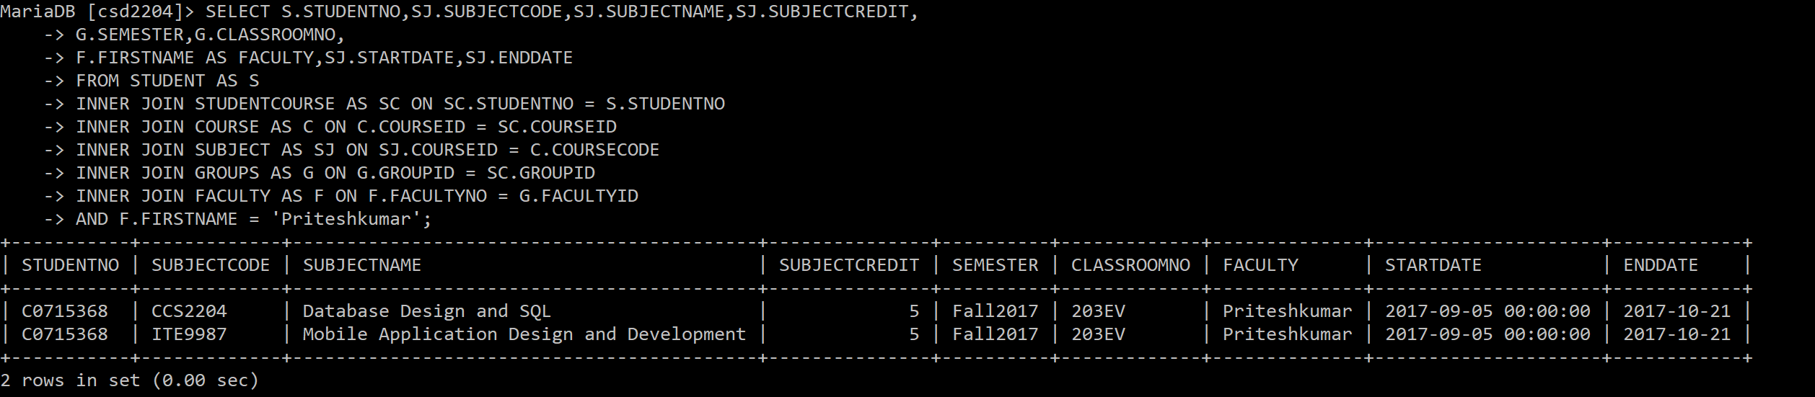

1. **LIST A PARTICULAR STUDENT MARK DETAILS**

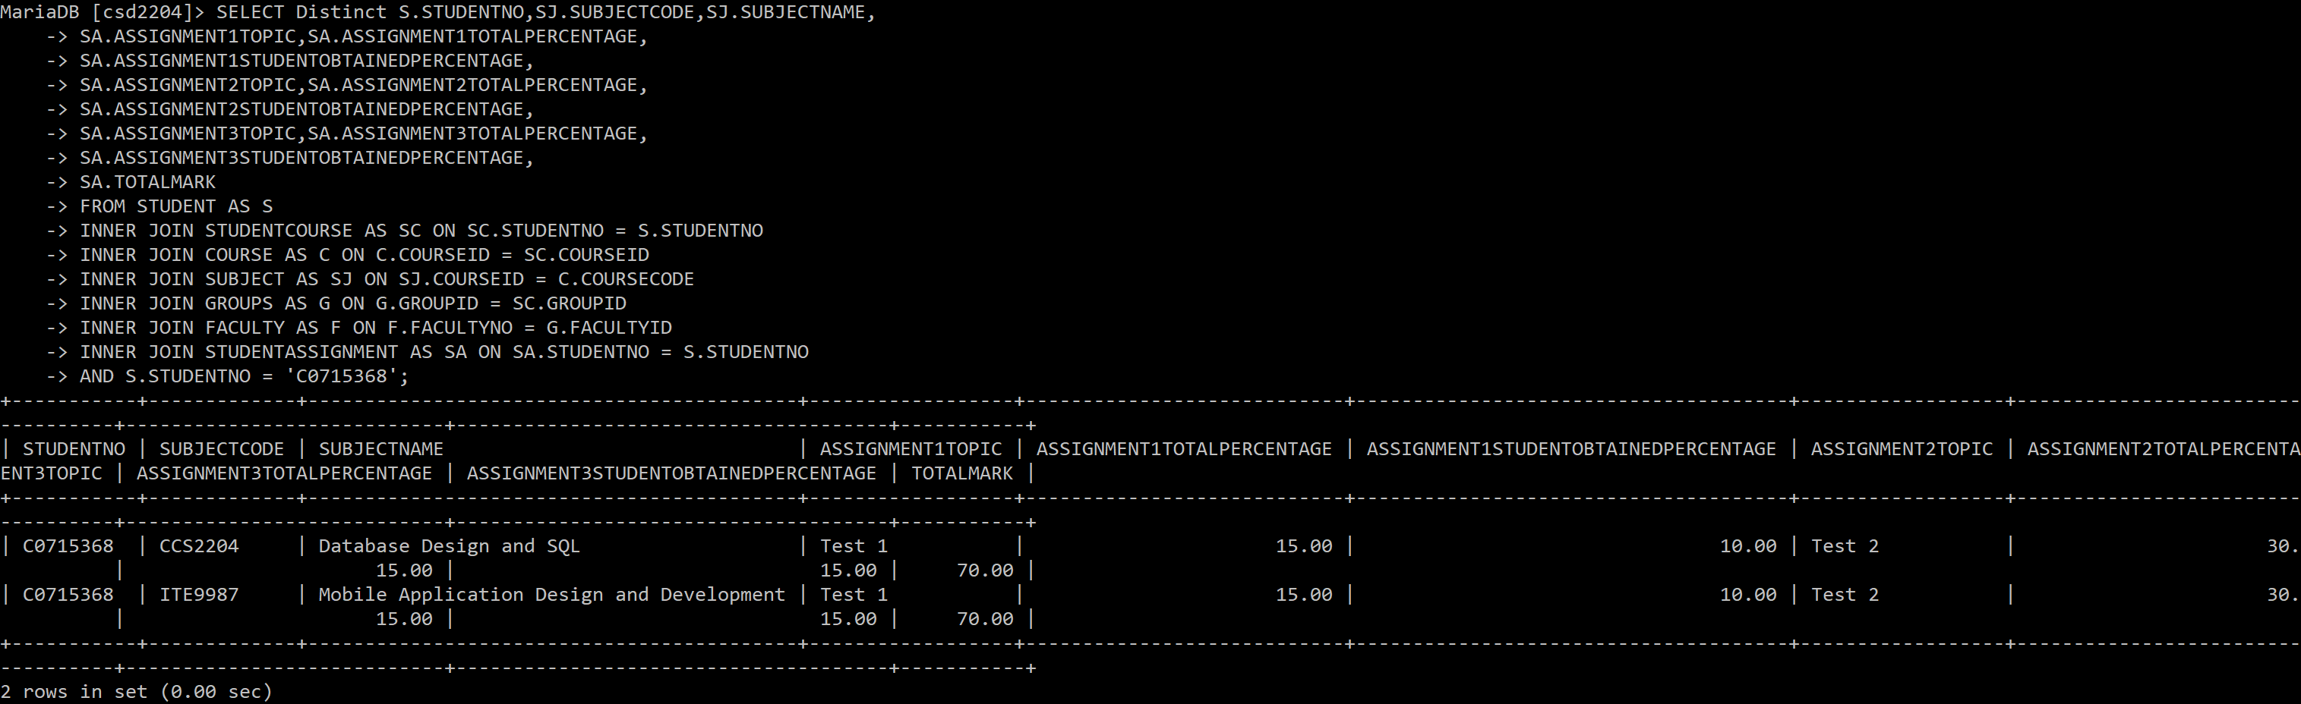

REFERENCES:

* <https://www.lucidchart.com/>
* <https://dev.mysql.com/>
* <http://www.slideserve.com/britanni-lowe/college-database-exercise>
* <http://www.powershow.com/view/2219-NzI5Z/SQL_Tutorial_powerpoint_ppt_presentation#.WcMJ0yBDaRo.gmail>
* <http://www.c-jump.com/bcc/common/Talk/SQL/SQL_20_DBdesign/SQL_20_DBdesign.html>
* https://www.w3schools.com/